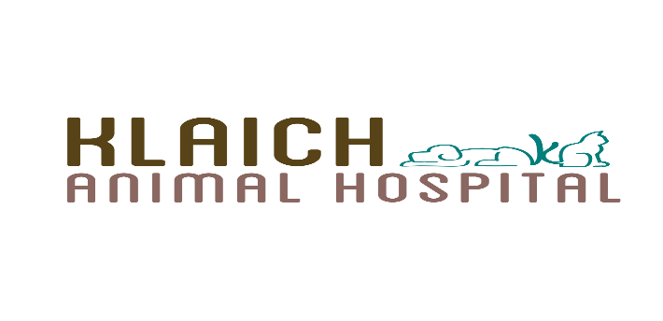
_______________________________________________________________________________________________________________________
Annual Exam Questionnaire
1. What brand of food do you feed your pet and how much do you feed?

2. Is your pet on any medication(s)? ___ No ___ Yes If so, please list.

3. Is your pet on any parasite preventatives? (e.g., flea/tick, heartworm) ___ No ___ Yes
If so, please list.
4. Do you provide any dental care for your pet? (e.g., dental cleanings, tooth brushing)
No___ Yes___ If so, please list. _________________________________ ___
5. Do you have any other pets? No___ Yes ___
If so, please list.
6. Describe your pet's lifestyle:
Indoor/Outdoor?
Lake, pond, river exposure? Hiking?
Dog Park?
Boarding/grooming?
Travel outside of Nevada?
7. Have you noticed any lumps or bumps on your pet? If so, please describe.

8. Have you noticed any of the following:
Coughing ___ Sneezing ___ Vomiting _ Diarrhea ___ Lethargy ___ Behavior Changes ___ Lameness ___ Pain ___ Increased thirst ___ Increased urination ___
Other
9. Are there any specific health issues you would like to discuss today?
If so, please list.
10. Any pertinent medical history? (e.g., vaccine reactions, anesthetic reactions, past surgeries, etc.)
If so, please list. ___________________________________________ _______
Contact information (please check your preferred point of contact)
___ Cell Phone: _______________ _ __ ____
___ Home Phone: _____________ _______
___ Email: __________________ _______

Thank you for allowing Klaich Animal Hospital to provide care for your pet. It is our commitment to help your pet have a longer, happier life. Part of that commitment includes providing preventative care for our patients. Preventative care includes annual examinations and wellness lab work. Wellness lab work can lead to early detection of disease and allows our doctors to establish a baseline to track your pet’s health from year to year. Please bring in a fresh fecal sample, as fecal testing and heartworm testing are included in the cost of the wellness lab work.
We look forward to seeing you and your pet. Please do not hesitate to reach out if you have any questions regarding your pet’s appointment or preventative care.

